Anti-Bullying and Anti-Violence Plan

Including Sexual Violence

2023-2024

School: | JOHN ADAM MEMORIAL SCHOOL
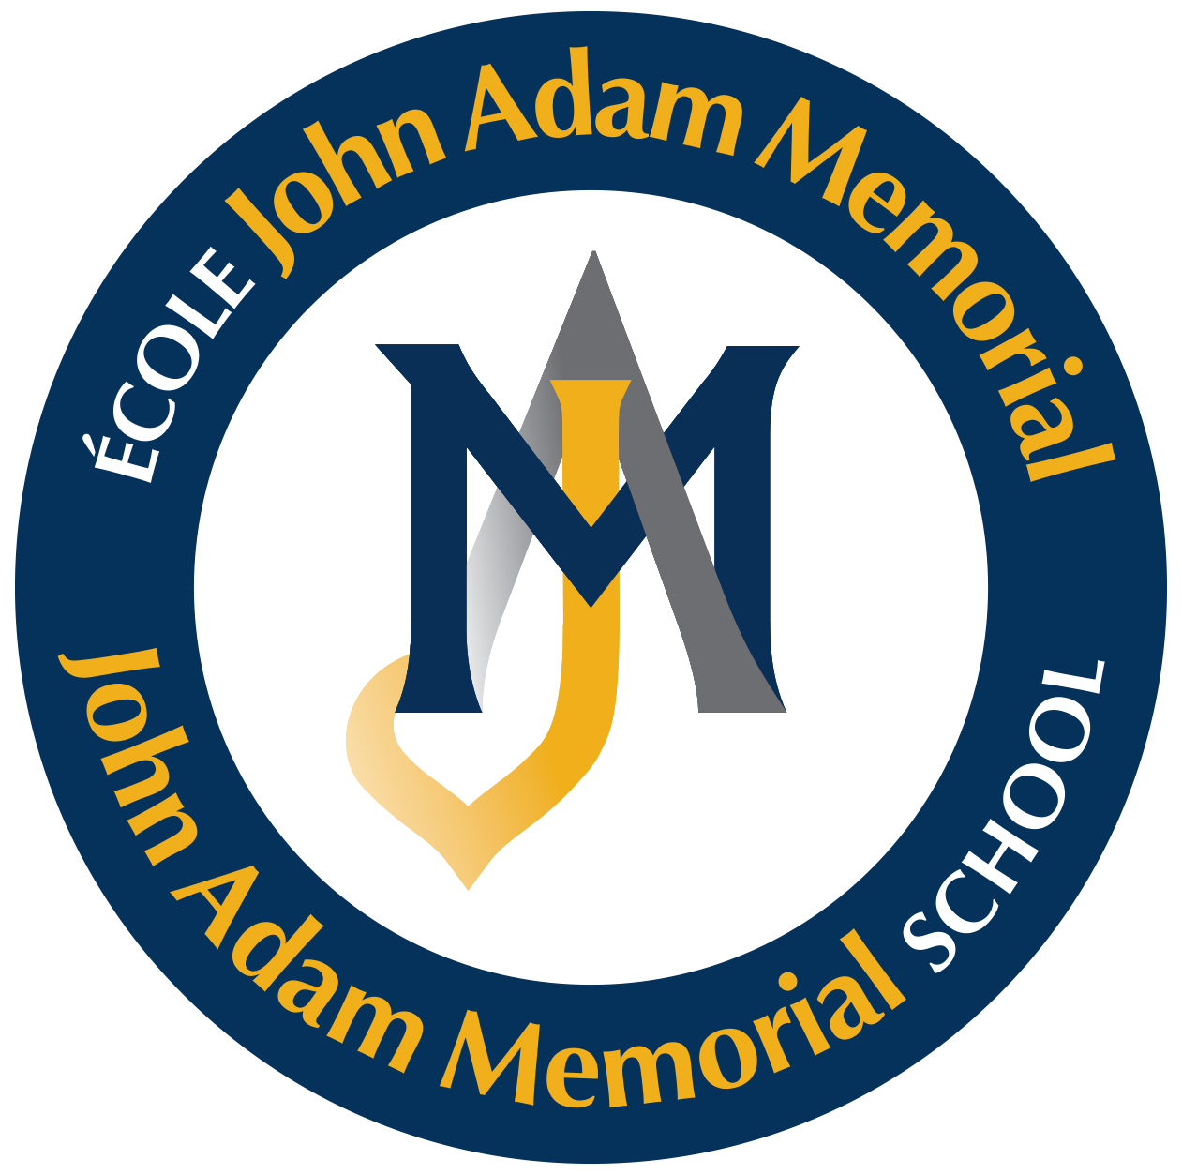

Coordinator : | Marie-Josée Dumont
AVAB Committee Members : | Steven Carroll, Principal
 | Yandy Macabuag, SET
 | Cassandra Savarad, Teacher
 | Simon Castonguay, Teacher
 | Katrina Boismier, Daycare Technician
Approved by Governing Board: | November 28, 2023
Resolution : | JAM 003-281123-003

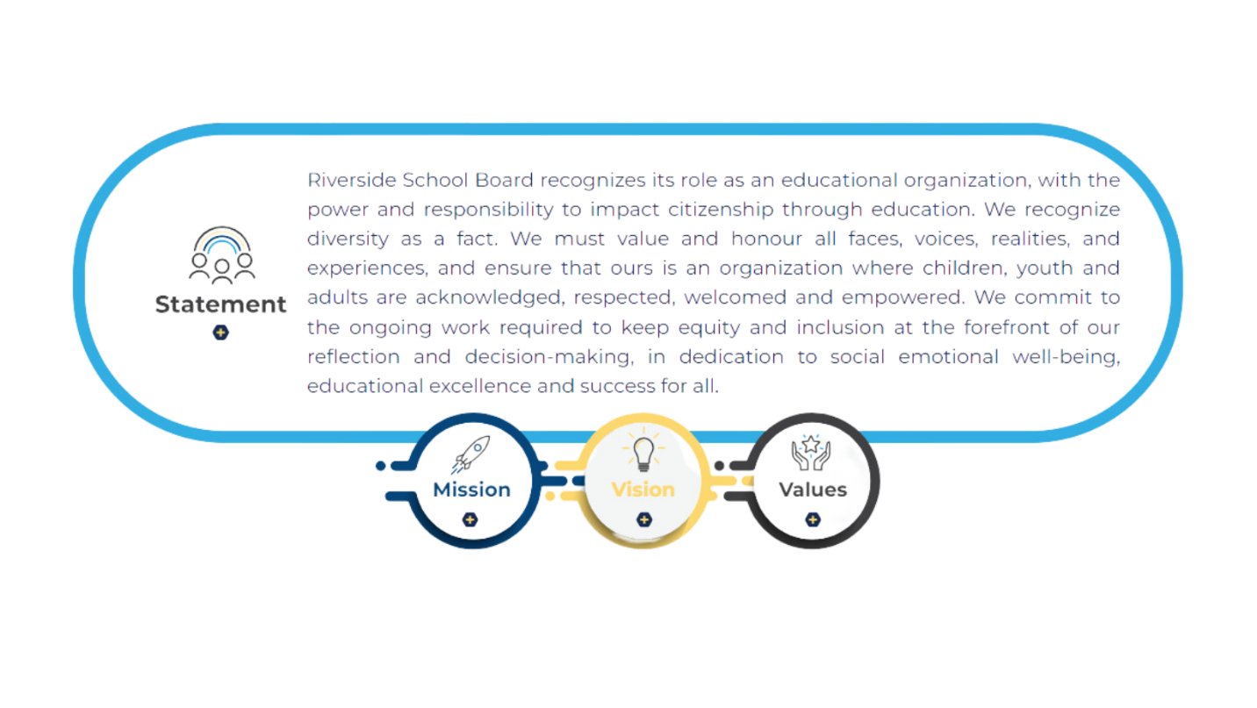

Anti-Bullying and Anti-Violence Plan
TABLE OF CONTENTS
Definitions
Bullying Violence Sexual Violence
Racism Discrimination
THE ELEMENTS OF THE ABAV PLAN:
Element 1 | Analysis of the Situation Prevailing at the School
Element 2 | Prevention Measures
Element 3 | Measures for Parent/Guardian Collaboration
Element 4 | Procedures for Reporting
Element 5 | Intervention Protocol  Staff Response Protocol  Student Response Protocol  Parent/Guardian Response Protocol
Element 6 | Measures to Ensure and Protect Confidentiality
Element 7 | Supervisory and Support Measures  (For the victim, bully, witness & bystander)
Element 8 | Specific Disciplinary Sanctions
Elements 9 | Follow-up Protocol
SEXUAL VIOLENCE
EXTRACURRICULAR
END OF YEAR EVALUATION
DEFINITIONS

Bullying
The word “bullying” means any repeated direct or indirect behaviour, comment, act or gesture, whether deliberate or not, including in cyberspace, which occurs in a context where there is a power imbalance between the persons concerned and which causes distress and injures, hurts, oppresses, intimidates or ostracizes. (Education Act Section 13(1.1)
http://www.education.gouv.qc.ca/en/current-initiatives/bullying-and-violence-in-the-schools/bill-56/
Violence
The word “violence” means any intentional demonstration of verbal, written,
physical, psychological or sexual force which causes distress and injures, hurts or oppresses a person by attacking their psychological or physical integrity or well-being, or their rights or property. (Education Act Section 13(3) http://www.education.gouv.qc.ca/en/current-initiatives/bullying-and-violence-in-the-schools/bill-56/
Sexual Violence
"The concept of sexual violence refers to any form of violence committed through sexual practices or by targeting sexuality, including sexual assault. It also refers to any other misconduct, including that relating to sexual and gender diversity, in such forms as unwanted direct or indirect gestures, comments, behaviours or attitudes with sexual connotations, including by a technological means." https://www.quebec.ca/en/education/prescolaire-primaire-et-secondaire/droits-eleve/report-an-act-of-sexual-violence-against-a-student
Racism
Racism means: “Racism corresponds to the “set of ideas, attitudes and actions whose purpose is to make ethnocultural and national groups feel inferior socially, economically, culturally and politically, thereby preventing them from benefitting fully from the advantages to which all citizens are entitled.” Racist discourse is usually based on real or presumed physical and cultural differences.” https://www.mifi.gouv.qc.ca/publications/fr/recherchesstatistiques/Pub_Immigration_et_demo_2015.pdf
Discrimination
Discrimination means:” Every person has a right to full and equal recognition and exercise of his human rights and freedoms, without distinction, exclusion or preference based on race, colour, sex, gender identity or expression, pregnancy, sexual orientation, civil status, age except as provided by law, religion, political convictions, language, ethnic or national origin, social condition, a handicap or the use of any means to palliate a handicap. Discrimination exists where such a distinction, exclusion or preference has the effect of nullifying or impairing such right.” (Charter of Human Rights and Freedoms, section 10). https://www.legisquebec.gouv.qc.ca/en/document/cs/c-12

ELEMENTS OF THE AV/AB PLAN

Element 1 | An analysis of the situation prevailing at the school with respect to bullying and violence;
Element 2 | Prevention measures to put an end to all forms of bullying and violence, in particular those motivated by racism or homophobia or targeting sexual orientation, sexual identity, a handicap or a physical characteristic;
Element 3 | Measures to encourage parents/guardians to collaborate in preventing and stopping bullying and violence and in creating a healthy and secure learning environment;
Element 4 | Procedures of reporting, or registering a complaint concerning, an act of bullying or violence to or with the institution and, more particularly, procedures for reporting the use of social media or communication technologies for cyberbullying purposes
Element 5 | The actions to be taken when a student, teacher or other school staff member or any other person observes an act of bullying or violence; or when a report or complaint is sent to the institution by the regional student Ombudsman
Element 6 | Measures to protect the confidentiality of any report or complaint concerning an act of bullying or violence;
Element 7 | Supervisory or support measures for any student who is a victim or bullying or violence, for witnesses and for perpetrator, (and bystander);
Element 8 | Specific disciplinary sanctions for acts of bullying or violence, according to their severity or repetitive nature, and;
Element 9 | The required follow-up on any report or complaint concerning an act of bullying or violence;

Element 1 | ANALYSIS OF THE SITUATION PREVAILING AT THE SCHOOL WITH RESPECT TO BULLYING AND VOILENCE

School Portrait
Student population : | 302
Other pertinent information:: | Insert data here
Immersion & English Stream programs: Groups are homogenous as there are no other groups to switch students. In same groups for 7 years.

Oasis Room (out of class support model) + JAM Café (Office for our In class support team)

Social Emotional Learning program (Zones of Regulation)

SWAT team (support staff discussions – including daycare)

Student Voice: Feedback from SV is integrated in our ABAV plan

Community Learning Centre School …possibility to facilitate interventions with community resources

Mindfulness Mondays

iHour…celebrating student interests

Health & Environmental Classes

Participation in SSIAA Activities

Multiple initiatives to sensitize to cultural issues (Orange Shirt, Walk for Wenjack, Black History and race relations sensitization, Pride Month, etc)

Empathy resources available for all staff.

Girl talk groups

JAM Merchandise allows for a strong sense of belonging.

JAM FAM (Parent Support webpage)

Moozoom : Social emotional learning program.

Get involved (theme and activities).

Outdoor Education

Analysis

An analysis of the situation prevailing at the school with respect to bullying and violence is conducted each year by using the following indicators:
- Review and analysis of GPI / ISM (digital reporting platform) entries related to bullying and / or violence
- Results from the latest Our School Survey (formerly Tell Them From Me).

Feel safe at school as well as to and from school
Students who feel safe at school as well as going to and from school. • 55% of students felt safe attending the school; the Canadian norm for these grades is 64%. • 57% of the girls and 53% of the boys felt safe attending the school. The Canadian norm for girls is 65% and for boys is 63%.

Students who perceived moderate to severe anxiety
Students who have intense feelings of fear, intense anxiety, or worry about particular events or social situations. • 43% of students in this school had moderate to high levels of anxiety; the Canadian norm for these grades is 22%. • 55% of the girls and 26% of the boys in this school had moderate to high levels of anxiety. The Canadian norm for girls is 27% and for boys is 18%.

Bullying and Exclusion
Students who are subjected to physical, social, or verbal bullying, or are bullied over the internet. • 36% of students in this school were victims of moderate to severe bullying in the previous month; the Canadian norm for these grades is 27%. • 41% of the girls and 26% of the boys in this school were victims of moderate to severe bullying in the previous month. The Canadian norm for girls is 26% and for boys is 29%

Students with a positive sense of belonging
Students who feel accepted and valued by their peers and by others at their school. • 80% of students in this school had a high sense of belonging; the Canadian norm for these grades is 77%. • 80% of the girls and 87% of the boys in this school had a high sense of belonging. The Canadian norm for girls is 75% and for boys is 79%.

Priorities
DIVERSITY: Race sensitization training for staff along with celebration of diversity initiatives for students:
Sexual orientation and LGBTQ2+ sensitization for students
Celebrate diversity initiatives (inserted in measures later in the document, special attention given to EHDAA), Black History Awareness, Sensibilisation à la réalité autochtone
Pride Month, Celebrate our Differences

SEL: Zones of Regulation implemented school wide. Moozoom online platform.

TRANSPORT: mTransport app to help parents track the bus movement. Also allows for supporting our initiatives to address Feel safe at school as well as to and from school. Remind Texting App supports parents with real time information.

SOCIAL MEDIA: TELUS training through CLC + Awareness for parents and social media

STUDENT TO STUDENT (STS) INITIATIVES: Playground leaders, mentoring from senior students to younger students.

OUTREACH TO PARENTS: Informing parents of our ABAV plan as well as resources to help them with the vocabulary behind the program. Also to support them with resources available to them via our JAM FAM (Family Aide Memoire).

Via our CLC CDA, this will help orientate our outreach to community stakeholders.

SCHOOL SUCCESS TEAM along with the assistance of the ABAV committee will support and oversee the educational project.

A major emphasis on Outdoor Education.

Element 2 | PREVENTATIVE MEASURES

To address the area(s) of concern, the following preventative measures aimed at putting an end to all forms of bullying and violence; in particular those motivated by racism or homophobia or targeting sexual orientation, sexual identity, a handicap or a physical characteristic include:

1- | Zones of Regulation
2 - | Moozoom

3 - | Student Voice Feedback

4 - | Playground Leader Program

5- | OASIS & JAM Café resources

6 - | Open Communication with Parents

7 - | Sheltered Lunches and Alternative Recesses

8 - | Diversity & Inclusion program for staff

9 - | Use of our JAM FAM webpage (Parent support interface) to educate them on issues we are dealing with at school

10 - | Chair (Marie-Josée Dumont) – preventative measures and sensitization campaign around school.

Element 3 | MEASURES FOR PARENT/ GUARDIAN COLLABORATION

The success of this plan depends on the understanding and support of all of our stakeholders. School administrators and staff play a key role in developing programs and strategies to improve daily school life. Students also have a responsibility to promote and support positive behaviours. Parents/ Guardians are equally important and necessary partners in this initiative. Parents/ Guardians are encouraged to be active advocates for their children and to be aware of changes in their behaviours and to contact the school when behaviours at home become a concern.

The following measures are aimed at encouraging parents/ guardians to collaborate in preventing and stopping bullying and violence and in creating a healthy and secure environment.

- The School’s Code of Conduct will be communicated with the parents/guardians (agenda, curriculum night, bulletins/memos, and/or on school website).

- The ABAV Plan will be explained and made available to parents/guardians; it will be posted on the school website, under the tab ABAV.

Ongoing communication between principal and / or their designate and parents/ guardians of children who are being bullied and those who are engaging in bullying behaviours until the resolution of the situation. Periodic communication with students who are bullied and their parent(s)/ guardian(s) to ensure that measures taken have been successful and the bullying has ceased.
Student Reflections sheets are sent home to inform parents of situations
Priority on calls and meeting with parents rather than simply receiving a written notice of situations.
Resources from PREVNET will be made available for parents
Resources from our School Library can be made available for parents
JAM FAM resource available on our website

Element 4 | PROCEDURES FOR REPORTING

The school will take the necessary measures to ensure confidentiality for all parties.

An incident of bullying and/or violence can be reported verbally (in person or by phone) or in writing (by email or by letter addressed to school administration). Students who wish to write a note to report an incident are encouraged to include their name for follow up.

Staff members who receive a report must document the information and submit the information to administration for follow up. On receiving a complaint concerning bullying or violence, and after considering the best interest of the students directly involved, the principal shall promptly communicate with their parents to inform them of the measures in the anti-bullying and anti-violence plan. The principal shall also inform them of their right to request assistance from the person specifically designated by the school board for that purpose.
Complaintsofficer@rsb.qc.ca Gary Tennant

When parents/guardians have been told about a bullying situation or an act of violence, they are expected to communicate with the school principal, an alternate administrator or the classroom teacher. The report will be documented. Following the investigation, the parent/guardian should be contacted and advised that the situation has been investigated and appropriate action has been taken. Details are divulged so as to maintain confidentiality.
ADDITIONAL NOTES

Student Reflections sheets are used for students to relate all details about a situation. Opportunities for

Restorative justice are incorporated within the Student Reflection sheet.

Resources can be made available to parents online through our JAM Family Aide-Memoire as well as through our online library (SORA).

Element 5 | INTERVENTION PROTOCOL

John Adam Memorial | is committed to providing a safe, caring and positive climate
Adult indifference is not-tolerated. School personnel must report and/or investigate all incidents of bullying and take appropriate action whether they personally observe incidents or learn of them by some other means. Reporting, investigation and action must occur even if the victim does not file a formal complaint or does not express overt disapproval of the incident.
This Intervention Protocol establishes practices and procedures for observed and reported incidents of bullying and/or violence.
For purposes of this Protocol, “Conduct” may include:
- Physical acts, such as inappropriate, unwanted, uninvited, or injurious physical contact with another; stalking; sexual assault; and destruction or damage to property of another;
- Written and electronic communication of any type that incorporates language or depictions that would constitute bullying, using any medium (including, but not limited to, cell phones, computers, websites, electronic networks, instant message, text messages and emails);
- Verbal threats made to another, including blackmail, extortion or demands for protection money;
- Direct or indirect, relationally aggressive behaviour such as social isolation, rumor spreading, or damaging someone’s reputation;
- Any of the above conduct which occurs off school grounds when such creates, or can reasonably be expected to create, a substantial disruption in the social setting and/or at school-sponsored activities and events.

In addition to the conduct described above, examples of conduct that may constitute bullying or violence include the following:
- Blocking access to school property of facilities;
- Stealing or hiding or otherwise defacing books, backpacks or other personal possessions;
- Repeated or pervasive taunting, name-calling, belittling, mocking putdowns, or demeaning humour relating to a student’s race, colour, gender, sexual orientation, ancestry, religion, disability, or other personal characteristics, whether or not the student actually possesses them, that could reasonably be expected to result in the disruption of school activities or that results in a hostile educational environment for the student.

Conduct that would not ordinarily be considered bullying or violence includes:
- Teasing
- “Talking trash”
- Trading of insults
The expression of ideas or beliefs that are protected by the Canadian Charter of Rights and Freedoms, so long as such expression is not lewd, profane, or intended to intimidate or harass another.

STAFF RESPONSE PROTOCOL
Any staff members who witness an act of bullying or violence must intervene immediately or as quickly as reasonably possible to address the issue.

The immediate safety and security of all parties must be ensured.

All incidents of bullying / violence must be reported to the principal, in a timely fashion.

A bullying/violence incident must be documented.

The school principal or their designate must investigate all reports in a timely fashion, preferably within 24 hours (when possible) of receiving initial report.

The staff person responsible for investigating the report about the behaviour should:

Interview student(s) exhibiting bullying behaviour and the target / victim(s) separately to avoid further victimization of the target.

Engage the target / victim first and focus on their safety.

Reassure them that the bullying behaviour will not be tolerated and that all possible steps will be taken to prevent a reoccurrence.

Offer the victim counselling (if needed).

Inform parents/guardians of the incident and subsequent intervention. (Details of the intervention or disciplinary actions are not to be shared in order to protect confidentiality).

STUDENT RESPONSE PROTOCOL
Any student who witnesses an act of bullying or violence has an obligation, as a responsible member of the school community, to intervene if the situation does not threaten their well-being, or to report the incident to school authorities.

The following are the means through which a student may do so:

Inform a staff member on duty.

Inform administration.

Mention it to a teacher or staff member they trust.

Tell parent/guardian.

PARENT / GUARDIAN RESPONSE PROTOCOL

Report the incident to a school administrator or classroom teacher.

*At the discretion of the principal or their delegate, police intervention may be
requested.

Element 6 | MEASURES TO ENSURE AND PROTECT CONFIDENTIALITY

Measures to protect the confidentiality of any report or complaint concerning an act of bullying or violence shall include:

- Staff is reminded that every incident and the ensuing follow-up must be kept confidential. This is done at least once each year.

- Reports of bullying and / or violence are recorded on a digital database that has restricted access.

- Use of intervention strategies that protect the anonymity of persons who report or provide information.

Element 7 | SUPERVISORY AND SUPPORT MEASURES  (for the victim, bully, witness & bystander)

It is the responsibility of every adult staff member to use difficult / challenging situations as opportunities to help students improve their social and emotional skills, accept personal responsibility for their learning environment, and understand consequences for poor choices and behaviours.

A clear distinction exists between remediation and consequences.
- Remediation, intended to counter or “remedy” a behavioural mistake, can be an effective prevention practice. Remediation measures are intended to correct the problem behaviour, prevent a reoccurrence, protect and provide support for the victim and take corrective action for documented systemic problems related to bullying and violence. Remediation measures allow the student an opportunity to reflect on behaviours, learn pro-social skills and make amends to those affected. Working with recovery plans and restorative justice practices are categorized as remediation.

- Consequences communicate to a perpetrator that their behavior is their choice and their responsibility. A consequence respects the child’s right to make a decision, even if it’s not a good one. It’s a matter-of-fact learning experience in which you maintain a better relationship with the child as you hold them accountable. Consequences are almost always enacted in conjunction with remediation measures and restorative practices. Measures should be applied on a case-by-case basis and take into consideration a number of factors including:

Student Considerations:

- Age and developmental maturity of the students involved;
- Nature, frequency and severity of the behaviours;
- Relationships of the parties involved;
- Context in which the alleged incidents occurred;
- Patterns of past or continuing behaviours;
- Other circumstances that may play a role.

School Considerations:

School culture, climate and general staff management of the learning environment;

Social, emotional and behavioural supports;

Student-staff relationships and staff behaviour toward the student;

Family, community and neighborhood situation;

Alignment with policies and procedures.

Examples of remedial measures and consequences may include, but are not limited to, the examples listed below:

Remediation Measures for Victims

Meet with counsellor / mentor / special education technician / administrator / staff member to:

Create a safe environment to allow victim to explore feelings about incident. Maintain open lines of communication.

Develop a plan to ensure student’s emotional and physical safety at school.

Ensure student does not feel responsible for the behaviour.

Ask student to log and report any and all future related incidents.

Offer counseling to help develop skills for overcoming the negative impact on self-esteem.

A staff member will conduct scheduled follow-up meetings with the student to ensure the bullying or violence has stopped and to provide support to the student. The degree of support offered at these meetings and their frequency shall depend upon the feedback from the victim regarding the current circumstances.

In all cases, it will be determined which members of the school staff must be made aware of the incident to ensure that the student is safe.

Parents/Guardians will be informed immediately following the incident and regularly updated until the situation is resolved.

Remediation Measures for Witnesses

Following the incident, an intervention may be held with any witnesses to determine their role in the incident. If the incident witnessed is severe, witnesses are met, in a group or individually, to debrief the event, discuss their role and to determine more appropriate actions in the future.

The school reserves the right to contact the parents/ guardians of bystanders.

As with victims, witnesses to acts of bullying or violence should have a reasonable expectation of feedback from intervening adult figures in a timely manner so as to guarantee a sense of safety and security in the school.

Remediation Measures for Student Exhibiting Bullying Behaviour

Develop an intervention plan with the student. Ensure the student has a voice in the outcome and can identify ways they can solve the problem and change behaviours.

Meet with parent(s)/guardian(s) to develop a recovery plan agreement to ensure all understand school rules and expectations, as well as the long term negative consequences of bullying or violence, on all involved, and to clearly outline the consequences if the behaviour continues.

Meet with special education technician, school counsellor, social worker or psychologist to:

Explore mental health issues or emotional disturbances – what is happening and why?

Offer additional social skills training such as impulse control, anger management, developing empathy and problem solving.

Arrange for apology – written is recommended.

Arrange for restitution – particularly if any personal items were damaged or stolen.

Determine restorative practices (age appropriate).

Remediation Measures for Student Bystanders

Review Student Response Protocol.

Explore reasons why they did not intervene or report the incident.

Offer of coaching on how to safely intervene or help the situation.

Element 8 | SPECIFIC DISCIPLINARY ACTIONS

Based on the severity and / or frequency of incidents and at the discretion of the administration, the following disciplinary and / or supportive/ corrective actions may include, but are not limited to:

Parent/ Guardian notification

Admonishment / conference with student (verbal warning)

Reflection activity or action

Recovery plan ~ Restorative measures or practices

Written warning and deprivation of privilege(s) / service(s)

Restitution

Mediation or conflict resolution (when deemed appropriate)

Probation and letter of expectations

Detention

In-school suspension

Out-of-school suspension

Referral to alternative to suspension program for schools offering such a program

Referral to counsellor, external social / medical agencies, for support

Legal action / report to law enforcement, if required

Signaling of youth protection

Convocation to a disciplinary hearing at the school board

School transfer

- Expulsion
Element 9 |  | FOLLOW-UP PROTOCOL

The principal or their designate will ensure that each incident was properly followed up on and documented. Follow-up measures will include the following:

- Verification that the incident has been properly documented.

- Verification that all parties immediately involved have been met with and that intervention protocols have been followed.

- Verification that parents/ guardians of the victims and perpetrators have been contacted.

- Meeting with the victim and perpetrator to assess their well-being, and that the bullying / violence has ceased.

- Verification of the completion of all remedial measures for all parties concerned.

- Referral of parents/guardians to complaints procedure, should the parents/guardians express dissatisfaction with the course of action from the school administration. In fact, it is possible to make a report or file a complaint concerning an act of bullying, violence or sexual violence to or with the regional student ombudsman and, for a person who is dissatisfied with the follow-up on a complaint filed with the institution, to use the complaint processing procedure provided for in the Act respecting the National Student Ombudsman (2022, chapter 17).

- For each complaint received concerning bullying or violence and each report received relating to an act of sexual violence, the principal shall send the director general of the school board a summary report on the nature of the incident and the follow-up measures taken. The summary report concerning an act of sexual violence shall also be sent to the regional student ombudsman.

SEXUAL VIOLENCE

Elements 1 to 9 of the present ABAV plan apply to acts of sexual violence, as adapted considering the circumstances.

PREVENTATIVE / SAFETY MEASURES TO STOP ACTS OF SEXUAL VIOLENCE

In addition to the prevention measures mentioned in Element 2, the following training activities for management and other personnel specific to acts of sexual violence include the following:

Training activities for management and other personnel include the following:

Training to be provided by the MEQ

SAFETY MEASURES TO STOP SEXUAL VIOLENCE
To address the area(s) of concern, the following measures aimed at putting an end to all forms of sexual violence include:

1 - | General school climate and Social Emotional Learning practices

2 - | Sexuality Health Education Curriculum and support from Consultant holding the dossier

3 -

4 -

5-

INTERVENTION PROTOCOL
For acts of sexual violence involving a perpetrator of 12 years of age or older, the administration must contact the pertinent department of the Riverside School Board prior to applying the intervention protocol (Element 5) and the Supervisory and Support Measures (Element 7) mentioned herein. Specific measures might be required in certain cases and the board will be of assistance to the administration as to the steps to follow.

FOLLOW-UP PROTOCOL
In addition to the follow-up protocol mentioned herein (Element 9), and more specifically, to the possibility of filing a report or making a complaint, in the case of a complaint concerning an act of sexual violence, the principal shall also inform the student who is the victim that it is possible to refer the complaint to the Commission des services juridiques. If the student is under 14 years of age, the principal also informs their parents/guardians of that option, and if the student is 14 years of age or over, the principal may also inform their parents/guardians of that option, with the student’s consent.

EXTRACURRICULAR SERVICES OR IMPLEMENTATION OF THE SPECIAL SCHOOL PROJECT

In addition to the measures mentioned above, the following measures will be included in all agreements between the school and a body or person providing extracurricular services or carrying out a special school project for the provision of services other than educational services:

PREVENTION MEASURES TO PREVENT AND STOP ANY FORM OF BULLYING OR VIOLENCE DURING THE PROVISION OF AND, WHERE APPLICABLE (Art 215 Bill 9)

Preventative measures could include:

1 - | Anti-bullying and anti-violence training by persons who would be required to work with minor students and persons regularly in contact with minor students

2 - | Guidelines on reporting any incidents of bullying, violence and or sexual violence will be reviewed by the administration of the school.

3 - | Service agreement

END OF YEAR EVALUATION

“83.1. Each year, the governing board shall evaluate the results achieved by the school with respect to preventing and dealing with bullying and violence. A document reporting on the evaluation must be distributed to the parents/guardians, the school staff and the Regional Student Ombudsman in charge of accountability assigned to the region in which the school is located.”

To ensure the integrity of its Plan, the administration of our school will conduct a yearly evaluation that reviews:

- The Our School Survey results.

- Revision and analysis of GPI / ISM (digital reporting platform) entries related to bullying and / or violence to assess decrease or increase in incidents of bullying and/or violence.

- The initiatives put in place for the year and assessment of effectiveness of the actions.

